**PYTHON: THE BIG PICTURE**

# Course Overview

## Course Overview

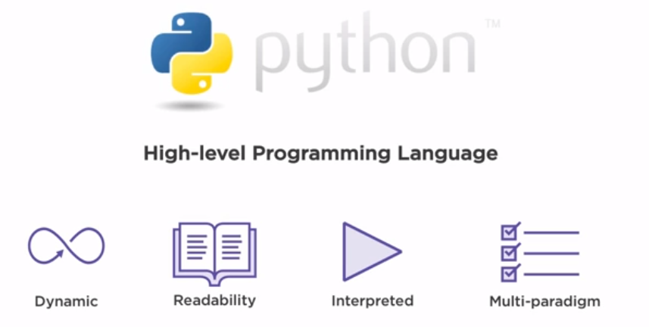

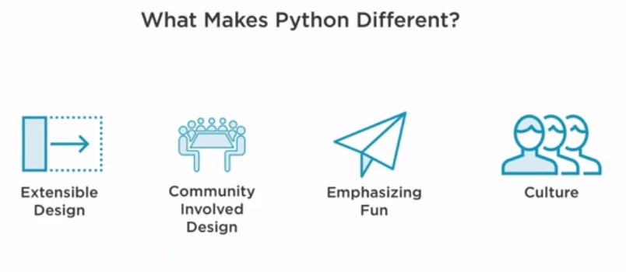

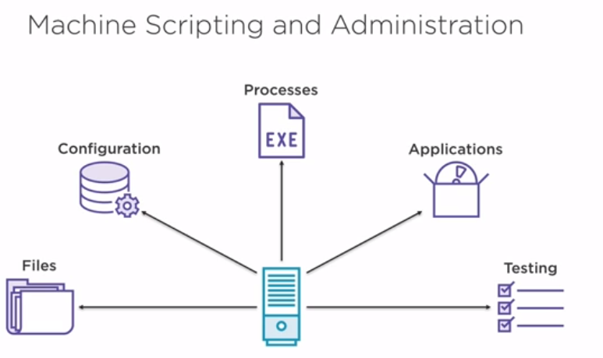

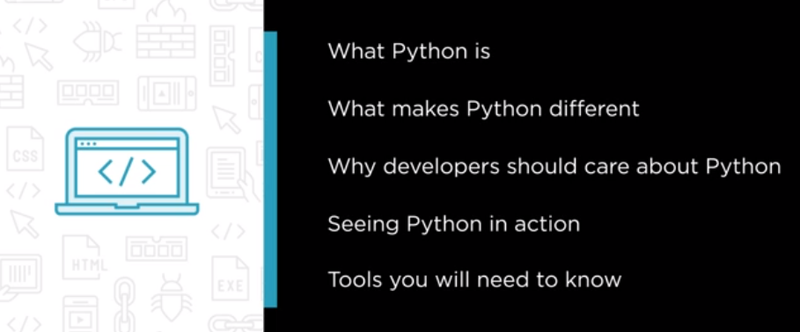

# What is python

## Introduction

## Getting the Most from This Course

## What is Python?

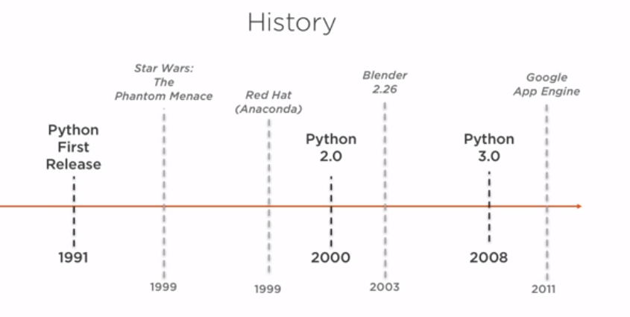

## Why Should Developers Care?

## What Makes Python Different?

## Summary

# When and Where is Python being Used?

## Introduction

## Linux Scripting and Administration

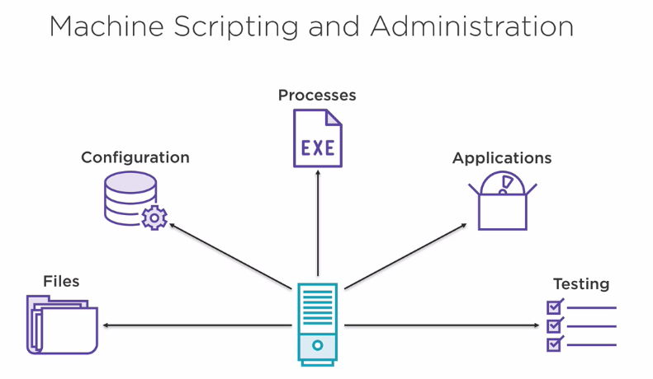

## Web Development

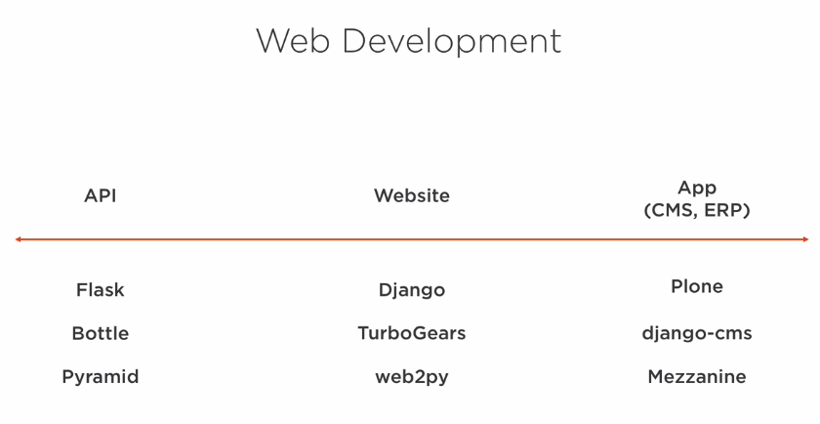

## Application Scripting

## Data Science

## Summary

# First Steps with Python

## Introduction

## The Basics

## Learning and Documentation

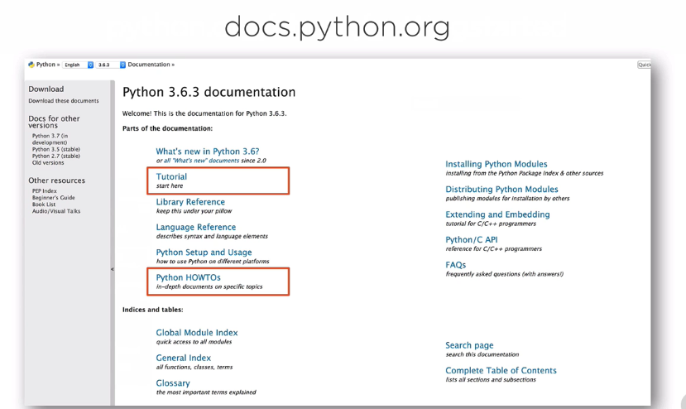

## Working with the Code of Others

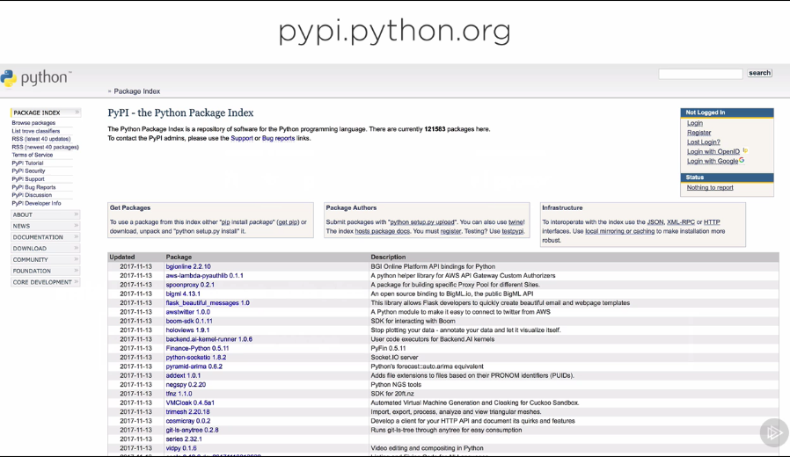

# Continuing Your Python Journey

## Introduction

## Python 2 vs Python 3

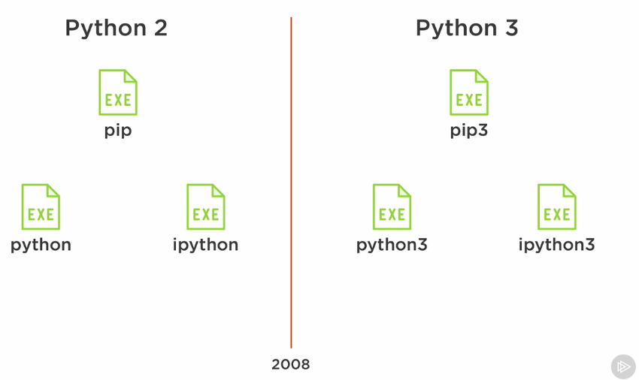

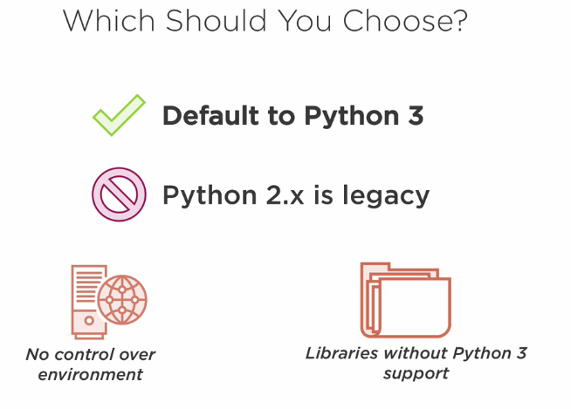

## Executing Python Code

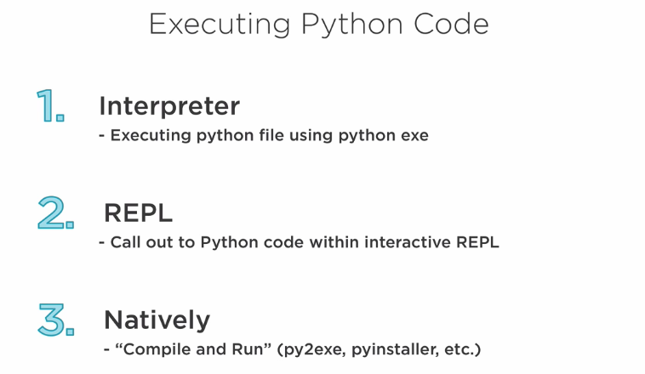

## Summary

